TABLE OF CONTENTS
- Executive Summary……………………………………………………………………………………2
- Problem Statement and System Overview………………………………………………..2&3.
. Project Definition: What is AgriShare SL?
. Real Challenges in Sierra Leone
. System Solutions and Core Value Propositions
- System Architecture……………………………………………………………………………………5
. Three-Tier Architecture Model
. Architectural Flow and Layer Separation
- Figma Interface Design and specifications……………………………………………6,7&8
.User Interface Design Methodology
.Detailed Description of the 10 Figma Screens
- .UML System Modeling………………………………………………………………………9,10&11
.Unified Modeling Language (UML) Model Descriptions
.UML Use Case Diagrams
- Strategic Operations and NGO Models………………………………………………………13
.Re-orienting Intermediares as Platform Value
.NGO Zero-Spoilage and Excess Crop Distribution Model
- Project Management and Timelines…………………………………………………………14,15
.Agile Project Lifecycle Framework
.12-Week Project Timeline and Critical Path Analysis
- Code Repository, SDLC Metrics and Licensing…………………………16,17,18,19&20
.Public GITHUB Repository and Collaboration
.Open-Source Licensing (MIT License Framework)
.Software Development Life Cycle (SDLC) – Agile
.UN Sustainable Development Goals (SDG)
.System Component Interaction and API Call Flow
- Conclusion………………………………………………………………………………………………21

Project Definition: What is AgriShare-SL?
AgriShare-SL is a decentralized digital platform designed to bridge the gap between rural smallholder farmers and urban buyers in Sierra Leone. The name "AgriShare" represents the core operational model:
"Agri" (Agriculture) and "Share" (shared logistics/collaborative transport pooling). It is a software solution designed to solve three critical agricultural supply chain failures:
- High transport costs through cooperative "Virtual Truck" logistics pooling.
- Trust and payment insecurity through a secure Mobile Money Escrow contract.
- Post-harvest food waste by connecting farmers directly to transport and urban marketplaces before crops spoil.

Decentralized Agricultural Supply Chain, Logistics Optimization, and Escrow System for Sierra Leone
Executive Summary
This report presents the system architecture, interface designs, database schemas, and implementation methodologies for AgriShare SL, a localized agricultural platform designed for Sierra Leone. AgriShare SL addresses high transport costs, post-harvest crop spoilage, and lack of transaction trust by introducing a digital escrow system linked to mobile money (Orange Money and Afrimoney), cooperative logistics pooling (Virtual Trucks), regional aggregation hubs, and multi-lingual voice guidance in Krio and other local languages in Sierra Leone. Operating on a secure three-tier software architecture, this platform redefines agricultural supply chains to promote economic security and inclusion.

Section 1: Problem Statement & System Overview
Smallholder farmers in rural regions of Sierra Leone, such as Kabala, Kailahun, and Kambia, face critical challenges in bringing their harvests to urban markets like Freetown:
1. High Logistics Overhead: Smallholder farmers cannot afford the high costs of hiring transport individually, resulting in crop spoilage on the farm.
2. Exploitative Middlemen: Intermediaries purchase crops at rock-bottom prices directly from farms and apply heavy markups at urban markets, leaving farmers with minimal profits.
3. Low Digital Literacy: Existing technology platforms rely on English text, excluding rural, non-literate farmers.
4. Transaction Risk: Lack of cash security leads to payment defaults and disputes between farmers, drivers, and buyers.

AgriShare SL resolves these issues with a targeted Software solution:
- Mobile Money Escrow: Buyer funds are locked via Orange Money and Afrimoney APIs when an order is placed, and only released when delivery is confirmed.

- Virtual Truck Logistics: The platform aggregates individual crop volumes (such as cassava, rice, and palm oil) into a single cooperative shipment up to a 150 bag truck limit for key routes (e.g., Kabala to Freetown).

- Krio Audio Playback: Text descriptions are supplemented by pre-recorded Krio audio clips, allowing users of all literacy levels to navigate the application.

- Middlemen as Value Providers: Intermediaries are registered as logistics drivers, storage partners, or hub verification agents, giving them stable incomes while removing predatory pricing.

Section 2: System Architecture
The application uses a Three-Tier Architecture to guarantee clean separation of concerns, data security, and stable performance over low-bandwidth networks:
1. Presentation Layer (Frontend): A lightweight Android mobile application and Progressive Web App (PWA) optimized for offline caching and audio file processing.
2. Application Layer (Backend API): A Node.js and Express backend engine handling business rules, user authentication, escrow states, and "Virtual Truck" routing logic.
3. Data Layer (Database): A relational PostgreSQL database ensuring transactional integrity, relational consistency, and complete historical logs.
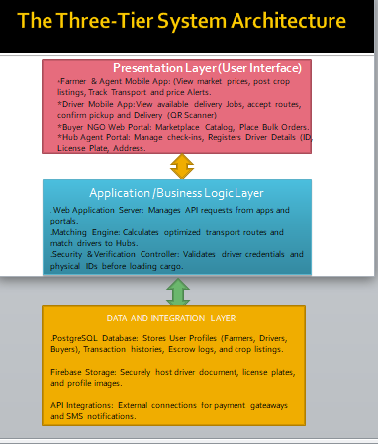
Figure 1: Three-Tier Architecture of AgriShare SL showing Presentation, Application, and Data Layers.

Section 3: Figma Interface Design & Functional Specifications
The user interface features 10 core screens designed to guide users through the workflow:

1. Screen 1: Login/Setup
The application landing screen, Allows the user to authenticate using their mobile phone number and select their language preference (English or Krio audio).
2. Screen 2: Register
Allows new users to enter their names, Mobile Phone Number and Select Language preference.
3. Screen 3: Role Selection
Defines the user profile types; Farmer, Buyer, Driver, or Hub Agent. This selection configures user permissions across the system.
4. Screen 4: Farmer Dashboard
The Farmers Home Screen, Displays active crops listings, payment records, and notifications about nearby cooperative trucks.
5. Screen 5: Sell Crops
An entry form for farmers to upload crop details: crop type, bag count/weight, pricing, and origin. Includes an Input fields for quality grades certified by Hub Agents.
6. Screen 6: Marketplace
The buyer’s facing marketplace. Shows verified listings organized by crop type, quality rating, location, and price.

7. Screen 7: Product Details
Displays comprehensive information for a selected listing, including farm-gate price, quality grade, and origin hub location. Features a prominent Krio voice playback button that reads the details aloud.
8. Screen 8: Cart and Checkout
Summarizes the selected items and displays the *Virtual Truck Logistics Meter. This progress bar shows how close the cooperative vehicle is to its **50-bag capacity*. Funds are locked in escrow upon checkout.
9. Screen 9: Driver Dashboard
The driver's portal showing assigned routes, pickup coordinates (Lorry Park Hubs), delivery destinations, and freight fee structures.
10. Screen 10: Active Trip and QR Delivery
Provides active trip status, displays a unique QR code. When the driver arrives, the buyer scans the code, which instantly prompts the system to release escrowed funds to the farmer and driver.

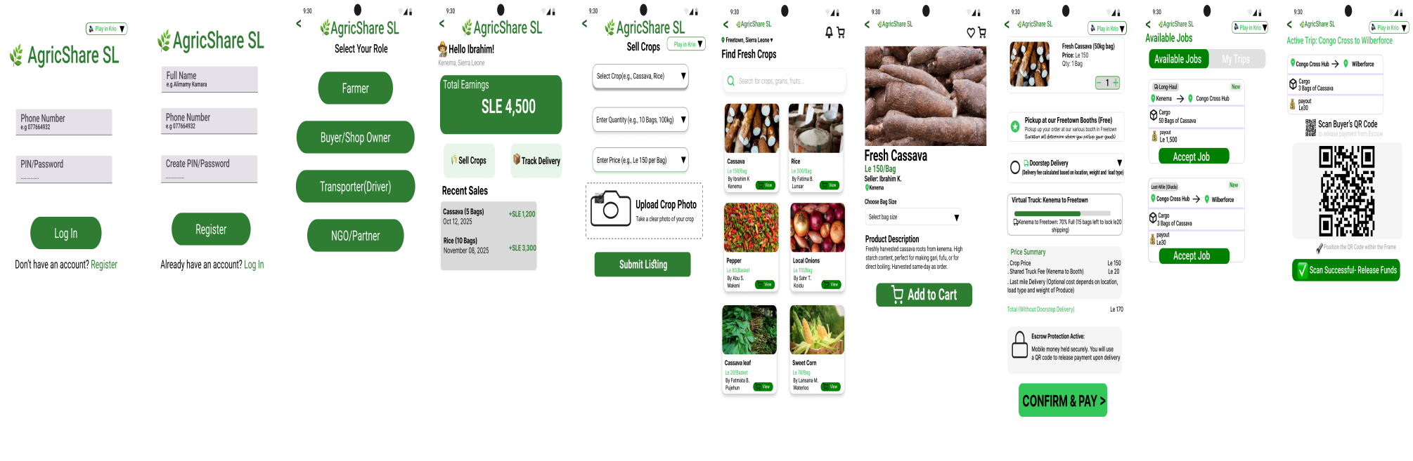
Figure 2: Figma Wireframe Layout and User Flow for AgriShare SL.

SECTION 4: SYSTEM DESIGN AND UML MODELING
This section outlines the architectural structure and behavioral flows of the AgriShare-SL platform using Unified Modeling Language (UML) diagrams. The following descriptions explain the system's actors, static data structures, operational workflows, and real-time message sequences, with the corresponding visual diagrams compiled at the end of this section.
- Use Case Diagram: Defines the system boundary and illustrates how the primary actors-Farmers, Buyers, Transporters, and Administrators-interact with the core functionalities of the AgriShare-SL platform, such as managing listings, initiating escrow payments, and tracking deliveries.

- Class Diagram: Represents the static database and object structure of the system. It details the core entities (including User, Crop Listing, Order, Escrow Contract, and Route), their specific attributes (variables), their operational methods (functions), and the relationships (associations and dependencies) between them.

- Activity Diagram: Illustrates the step-by-step operational workflow of the platform. It tracks the dynamic flow of activities from the initial crop listing by the farmer, through secure escrow deposit and logistics routing, to final delivery verification and automated payment release.

- Sequence Diagram: Details the chronological, step-by-step interaction and message exchanges between key system components (Client Ul, Backend API, Database, and Block-chain Escrow Smart Contract) during a standard crop purchase and delivery transaction lifecycle.

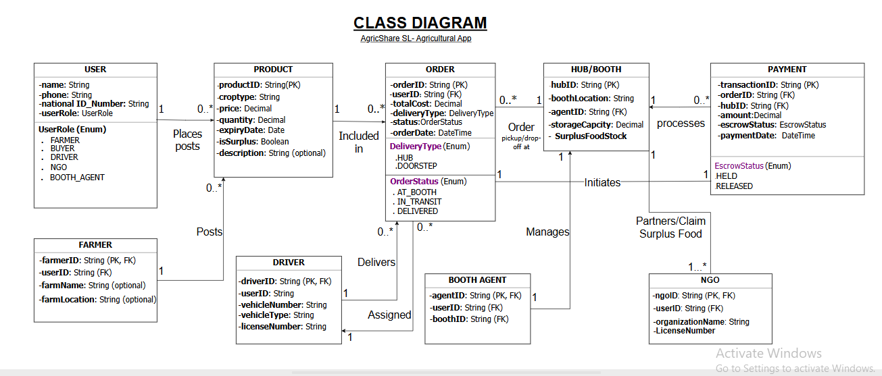
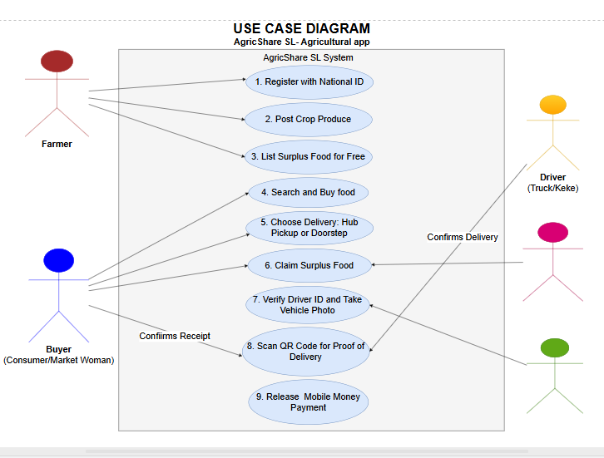
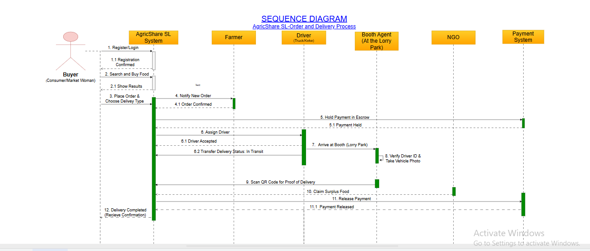

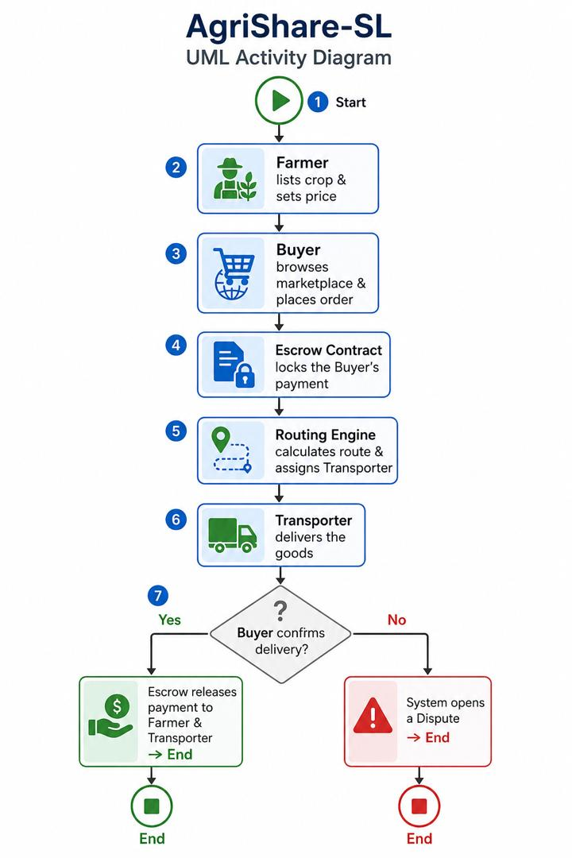

Section 5: Strategic Operations: Middlemen Integration & NGO Zero-Spoilage Model
AgriShare SL shifts the role of traditional middlemen to align them with the platform's goals:
Logistics Partners: Local truck operators register their vehicles to haul bulk cargo, earning guaranteed freight fees based on distance rather than buying and reselling crops at high markups.
Hub Agents: Local agents staff lorry park aggregation booths to weigh crops, confirm quality grades, and check driver credentials.

Section 6: Project Management, Gantt Chart, and Activity Network Diagram
AgriShare SL was developed using an Agile framework over a 12-week development lifecycle. The dependency between interface design and backend API integration places the project on a critical path with zero float time.
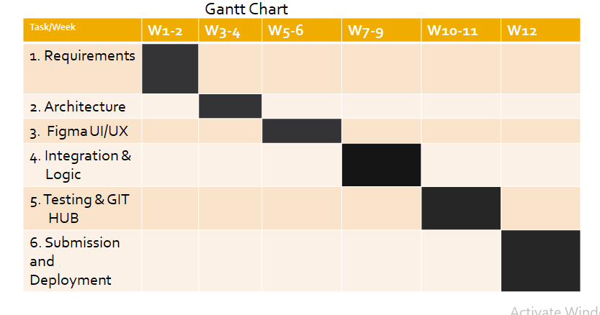
Figure 4: 12-Week Agile Project Gantt Chart.

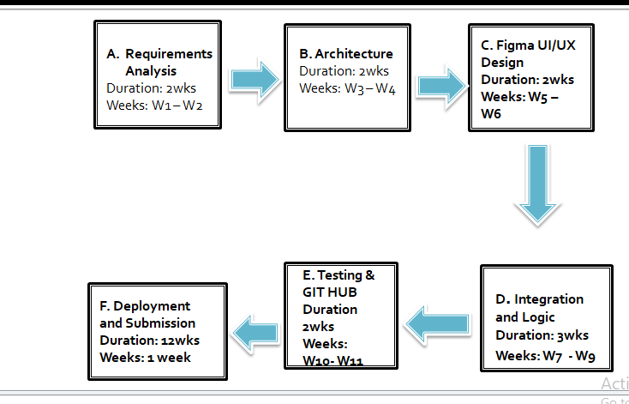Figure 5: Project Network Diagram showing Critical Path from Requirements to Deployment.

Section 7: Code Repository & Open Source License
To support community development and public sector adaptation in Sierra Leone, the AgriShare SL codebase is hosted in a public GitHub repository.

GitHub Repository URL: blessedbbyedn247-tech/AgriShare-SL

Open-Source Licensing: MIT License
The AgriShare SL platform is released under the permissive MIT License. This license was selected to establish the platform as a Digital Public Good, allowing local developers, agricultural cooperatives, NGOs, and government agencies in Sierra Leone to freely adapt and scale the system.
- Permissive Use: Anyone has the right to copy, modify, merge, publish, distribute, and sell the software without paying licensing fees.
- Attribution: The only requirement is that the original copyright notice and this permission notice must be included in all copies or substantial portions of the software.
- No Liability: The software is provided "as is," without warranty of any kind. The original developers are protected from any legal claims or liability.

Software Development Life Cycle (SDLC) - Agile Model
For the development of AgricShare SL, we chose the Agile Development Model. Agile allows for iterative development, meaning we can build, test, and adapt features quickly based on user feedback. This is crucial for a project in Sierra Leone where infrastructure and user digital literacy require constant adjustments.

Agile Phases for AgricShare SL:
1. Requirements Gathering: We analyzed the challenges of rural farmers and buyers in Freetown. We identified key constraints: high transportation costs, middleman exploitation, low digital literacy, and internet connectivity issues.
2. System Design: We designed the database schema to support shared transportation (aggregation) and mapped out the three-tier system architecture. We selected Orange Money and Afrimoney for payment integrations.
3. UI/UX Prototyping: We designed the 10-screen user flow in Figma. Based on early feedback, we added Krio voice notes to assist semi-literate farmers and a 'Virtual Truck' progress bar to show shared shipping status.
4. Integration & Testing: We modeled the escrow system logic, ensuring money is held safely until the driver's QR code is scanned upon delivery.
5. Review & Handoff: The system was packaged, the repository was initialized on GitHub, and the documentation was finalized for university submission.

Agile Diagram

SDG Relevance (Sustainable Development Goals)

AgricShare SL is directly aligned with three United Nations Sustainable Development Goals:
1. SDG 2: Zero Hunger (Target 2.1 & 2.3): By building a 'Virtual Truck' aggregation engine, we prevent agricultural waste. Farmers can transport fresh crops to urban centers before they spoil. Additionally, the 'Donated Surplus' checkout allows NGOs to claim free food near spoilage, helping to feed vulnerable communities.
2. SDG 8: Decent Work & Economic Growth (Target 8.5): The app provides a sustainable source of income for local youth who act as 'AgricShare Agents' assisting farmers. It also provides reliable courier jobs for Okada and Keke riders through the last-mile dispatch system.
3. SDG 12: Responsible Consumption and Production (Target 12.3): The platform bypasses exploitative middle-men who artificially inflate market prices, connecting consumers directly to producers. This builds a highly transparent, efficient, and ethical agricultural supply chain in Sierra Leone.

Component Interaction Flow:
1. The Buyer confirms an order on the Frontend, choosing mobile money checkout.
2. The Backend receives the request and contacts the Mobile Money API to place the funds into Escrow.
3. The Backend records the order in the Database and checks if the Aggregation Engine threshold (the virtual truck) is met.
4. Once the truck is full, the Backend triggers the SMS Gateway API to text the buyer their pickup code and routes the job to the Driver's App.
5. Upon delivery, the driver scans the buyer's QR Code, notifying the Backend to trigger the Mobile Money API to release the funds from escrow to the farmer and drive

Section 8: Conclusion
AgriShare SL addresses key structural inefficiencies in Sierra Leone's agricultural supply chains. By implementing secure mobile money escrows, cooperative transport options, regional hubs, and Krio voice guidance, the platform creates a transparent marketplace that protects farmer earnings, coordinates local logistics, and reduces post-harvest waste.

